Evaluating the impact of Large Language Models in Further Education

Saadia Adnan

Abstract:
This study explores the role of AI tools, particularly those powered by Large Language Models (LLMs), in transforming teaching within Further Education (FE) in the UK. Focusing on TeacherMatic, an AI-driven planning tool, it evaluates real-world usage by lecturers through a mixed-method approach at New City College. The research analyses engagement trends, shifts in staff perception, and practical outcomes of AI adoption. Key findings reveal that AI can support efficient, personalised teaching while raising important ethical considerations around data use. The study offers practical recommendations for integrating AI tools into FE teaching in a responsible and impactful way.

Introduction

This research explores how AI-driven Large Language Models (LLMs), particularly TeacherMatic, influence teaching practices in UK Further Education (FE).
Problem: While AI is widely studied in higher education, its application in FE remains under-researched, especially real-world classroom use.
Research question: Can LLMs effectively enhance teaching and learning in FE?
Focus and Boundaries: The study focuses on one FE institution, using surveys and usage data. It does not explore technical AI mechanisms.
Fit with other research: Builds on AI-in-education literature, offering new empirical insights specific to the FE context.

Data analysis Results

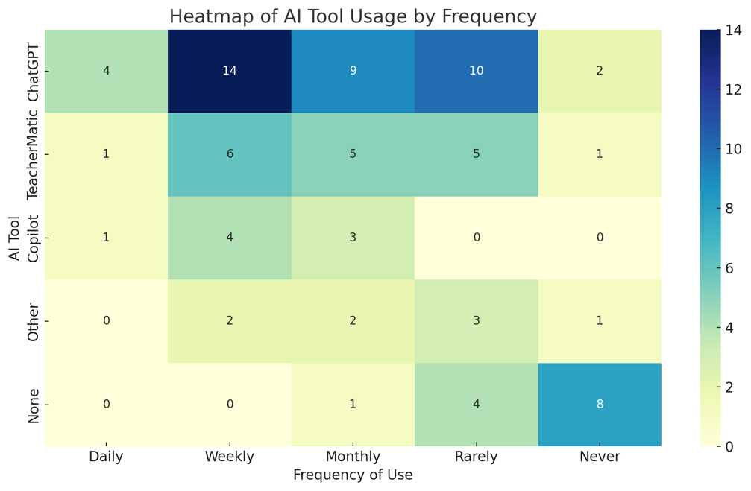
Chi-Square Test Heatmap of AI Usage by Frequency

Methodology & Ethical Consideration

- Research Design: A mixed-method approach was used, combining quantitative data (usage logs) and qualitative data (surveys) to evaluate AI tool adoption in Further Education.
- Type of Study: Mixed-method: integrating both qualitative insights and quantitative analysis.
- Population & Sampling: Targeted 601 teaching staff at New City College across four campuses. 73 responses were collected via stratified email distribution.
- Data Collection & Analysis: Surveys, institutional reports, and TeacherMatic login data were analysed using statistical tools (Chi-square, ANOVA) and thematic coding (Python in Google Colab).
- Ethical Statement: Ethical approval was obtained. Participation was voluntary, anonymous, and GDPR-compliant, ensuring no harm to participants.

Discussion/Conclusion (Strengths and Limitations)
- Findings & Hypothesis: The study supports the hypothesis that AI-driven Large Language Models (LLMs), particularly TeacherMatic, enhance teaching practices in Further Education (FE). Educators reported improved lesson planning, reduced administrative workload, and moderate gains in learner engagement. Statistical analysis confirmed a significant relationship between tool type and usage frequency.
- Comparison with Literature: These findings align with prior research (e.g., Gan et al., 2023; Holmes et al., 2019), which highlights AI’s potential to streamline educational tasks. However, unlike higher education, FE adoption remains cautious, with most usage limited to planning and resource creation.
- Significance: This study contributes original empirical evidence from the under-researched FE sector. It offers practical insights into AI integration, informing institutional strategies, professional development, and ethical considerations for AI use in education.
- Limitations: The study is limited to one institution (New City College), which may affect generalisability. The 12.15% survey response rate introduces potential bias, and reliance on self-reported data may not fully reflect actual usage. Additionally, the absence of student perspectives and the short evaluation period limit the depth of impact assessment.

Future Recommendations
- Conduct multi-institutional studies to improve generalisability across the FE sector.
- Implement longitudinal research to assess long-term impacts of LLMs on teaching and learning.
- Include student perspectives to evaluate learner engagement and outcomes.
- Explore subject-specific effectiveness of AI tools across STEM, humanities, and vocational areas.
- Develop ethical frameworks and data privacy protocols tailored to AI in education.
- Investigate effective CPD models to enhance AI literacy among educators.
- Compare AI tools (e.g., ChatGPT, Copilot, TeacherMatic) to assess usability, effectiveness, and educator preferences.

Future Recommendations
- Conduct multi-institutional studies to improve generalisability across the FE sector.
- Implement longitudinal research to assess long-term impacts of LLMs on teaching and learning.
- Include student perspectives to evaluate learner engagement and outcomes.
- Explore subject-specific effectiveness of AI tools across STEM, humanities, and vocational areas.
- Develop ethical frameworks and data privacy protocols tailored to AI in education.
- Investigate effective CPD models to enhance AI literacy among educators.
- Compare AI tools (e.g., ChatGPT, Copilot, TeacherMatic) to assess usability, effectiveness, and educator preferences.
Let me know if you'd like this formatted for your dissertation!

References
Association of Colleges (2024). AOC Annual Conference and Exhibition: TeacherMatic. Pearson. https://www.aoc.co.uk/teachermatic
Baker, T., Smith, L., & Anissa, N. (2019). Educ-AI-tionRebooted? Exploring the future of AI in schools and colleges. Nesta. https://media.nesta.org.uk/documents/Future_of_AI_and_education_v5_WEB.pdf
Bola. S. (2025). Exploring the Integration of Generative AI in Further Education Teaching Practices. ResearchGate. https://www.researchgate.net/publication/388642402_Exploring_the_Integration_of_Generative_AI_in_Further_Education_Teaching_Practices_Cite_as_Bolla_S_2025_Exploring_the_Integration_of_Generative_AI_in_Further_Education_Teaching_Practices
Felix, J. Webb, L., (2024). Use of artificial intelligence in education delivery and assessment.
Research Briefing. UK parliament POST. DOI: https://doi.org/10.58248/PN712
Gajjar, D. (2023). Artificial Intelligence: An explainer. UK Parliament POST.
DOI: https://doi.org/10.58248/PB57
Gan, W., Qi, Z., Wu, J., & Lin, J. C. (2023). Large Language Models in Education: Vision and opportunities. https://arxiv.org/pdf/2311.13160
UK Parliament POST. (2024). Artificial Intelligence, education and impacts on children and young people. https://post.parliament.uk/artificial-intelligence-education-and-impacts-on-children-and-young-people/
Vygotsky, L.S. (1978). Mind in society: The development of higher psychological processes (M. Cole, V. John-Steiner, S. Scribner, & E. Souberman, Eds.). Harvard University Press.
Yan, L., Sha, L., Zhao, L., Li, Y., Martinez-Maldonado, R., Chen, G., Li, X., Jin, Y., & Gasevic, D. (2023). Practical and ethical challenges of large language models in education: A systematic scoping review. British Journal of Educational Technology. https://www.researchgate.net/publication/372530702_Practical_and_ethical_challenges_of_large_language_models_in_education_A_systematic_scoping_review#fullTextFileContent

